Developmental Biology Review (2018)

# The Cerebral Cortex

## Two Major Types of Neural Progenitor Cells：

1. Radial glial cells (RGCs, polar, asymmetric division, VZ)
2. Basal progenitor cell (BPCs, non-polar, symmetric division, SVZ)

## Two Putative Models for Layer Formation during Cortical Neurogenesis

Skin-like (out-pushing) and Brick laying (inside-out✓)

## Cell fate determination of Cortical NPCs

1. Progressive fate restriction: Common multipotent NPCs generate cortical projection neurons sequentially.
2. NPC heterogeneity: Distinct types of NPCs for lower and upper layer neurons.

## Assays to Study Cell Fate Determination of Cortical NPCs

1. Transplantation assays (using 3H-Thymidine labeled Cortical NPCs, multiple types of cells could be tested)
2. *In vitro* differentiation (using layer-specific markers, multiple types of cells could be tested)
3. Retroviral labeling and lineage tracing (too few clones were traced)
4. Genetic lineage tracing (precisely controlled)

## Cell Lineage Tracing

1. A careful assessment of the cells that are marked at the initial time point, so that the starting populations are clearly defined.
2. The markers used to mark the cells remain exclusively in the original cells and their progeny and will not diffuse to the neighboring cells.
3. These markers are sufficiently stable and are not toxic to the cells during the entire tracing period.
4. Observational methods: direct observation, dye marking, genetic labeling (chimeric embryos, transgenic DNA chimeras, Cre-*LoxP* system, Mosaic Analysis with Double Markers (MADM))

## Why do Human brains have Much Larger Size and Cortical Surface Area than Rodents?

1. Increase in the founder stem cell population.
2. Increased rounds of transit amplification.
3. Longer period of neurogenesis.

## Microcephaly

1. Depletion of founder stem cell population.
2. Decreased rounds of transit amplification.
3. Shorter period of neurogenesis.

## Adult neurogenesis

Occurs in subventricular zone and dentate gyrus of hippocampus.

## Key Facts in Cortical Development of Cerebrum

1. Cortical projection neurons arise (directly or indirectly) from progenitor cells lying closely to the ventricle.
2. New-born neurons migrate radially (outward) along the radial fibers of radial glial cells (RGCs).
3. Late-born neurons are laid on top of new-born neurons (inside-out): I → VI → V → IV → III/II.
4. Gliogenesis follows neurogenesis.
5. Precise neuronal migration ensures proper cortical layer formation.
6. Interneurons are generated from the ventral part of the forebrain and migrate tangentially to the cortex.

## The Path to a Functional Organ

1. The nervous system and the brain.
2. Neural induction and neural tube formation.
3. Patterning of the nervous system — dorsal—ventral; anterior—posterior.
4. Cortical development: neurogenesis and gliogenesis.
5. Neuronal maturation: polarity, axon growth and pathfinding.
6. Make the right and functional neural connections, synaptogenesis, myelination.

## QUIZ

### Characteristics of major types of neural progenitor cells in cortical development.

Two major types of neural progenitor cells are radial glial cells (RGCs) and basal progenitor cells (BPCs). Radial glial cells are bipolar-shaped cells that span the width of the [cortex](https://en.wikipedia.org/wiki/Cerebral_cortex) in the developing vertebrate central nervous system (CNS) and serve as primary progenitor cells capable of generating neurons. Most neural progenies are derived from radial glial cells. Basal progenitor cells are a type of secondary progenitor cell in the developing cerebral cortex. Radial glial cells divide asymmetrically in the ventricular zone (VZ), while progenitor cells divide symmetrically in the subventricular zone (SVZ).

### What is the experimental evidence showing the generation of layer-specific neurons is majorly cell-

autonomous?(畅畅)

The determination of laminar identity (i.e., which layer a cell migrates to) is made during the final cell division. Newly generated neuronal precursors transplanted after this last division from young brains (where they would form layer 6) into older brains, whose migratory neurons are forming layer 2, are committed to their fate and migrate only to layer 6. However, if these cells are transplanted prior to their final division, they are uncommitted and can migrate to layer 2.

### What’re the underlying cellular mechanisms governing the expansion of human cortex?

* 1. Cortical projection neurons arise (directly or indirectly) from progenitor cells lying closely to the ventricle.
  2. New-born neurons migrate radially along the radial fibers of radial glial cells (RGCs).
  3. Late-born neurons are laid on top of new-born neurons (inside-out): I → VI → V → IV → III/II.
  4. Gliogenesis follows neurogenesis.
  5. Precise neuronal migration ensures proper cortical layer formation.
  6. Interneurons are generated from the ventral part of the forebrain and migrate tangentially to the cortex.

### How to prove there’re neural stem cells in adult brains?(畅畅)

Thymidine analogs, such as bromodeoxyuridine (BrdU), are incorporated in newborn cells in their last DNA replications. Use immunofluorescent labeling for BrdU and for one of the neuronal markers (e.g. NeuN, calbindin, neuron specific enolase (NSE)) to determine whether there are new neurons generated from dividing progenitor cells in the dentate gyrus of adults.

### What is lineage tracing/fate mapping? What are common means to perform lineage tracing?

Lineage tracing is a method that delineates all progeny produced by a single cell or a group of cells. In a lineage-tracing experiment, the cells of interest are marked at one time point, and the progeny derived from these marked cells are revealed at a later time point. Common means include direct observation, dye marking, genetic labeling (chimeric embryos, transgenic DNA chimeras, Cre-*LoxP* system, Mosaic Analysis with Double Markers (MADM)).

### How to perform genetic lineage tracing?

Chimeric embryos, transgenic DNA chimeras, Cre-*LoxP* system, Mosaic Analysis with Double Markers (MADM)

# Neural Crest Cells

## Features of Neural Crest Cells (NCCs)

1. Derived from the ectoderm (neural fold)
2. A transient structure
3. Undergo an epithelial-mesenchymal transition (EMT) and delamination from the dorsal neural tube
4. Neural crest cells produce a variety of tissues (both mesoderm and ectoderm)

## Specification of Neural Crest Cells

1. Neural crest cells first appear at the border between the presumptive epidermis and neural plate.
2. The anterior border tissue becomes placode, which generates eye, ear, nose, and other sensory organs.
3. The timing of BMP and Wnt expression is critical for discrimination between neural plate, epidermis, placode, and neural crest tissues.
4. Inductive mechanisms (FGF, BMP, Notch and Wnt signaling) — mesoderm, interaction between neural and non-neural ectoderm.

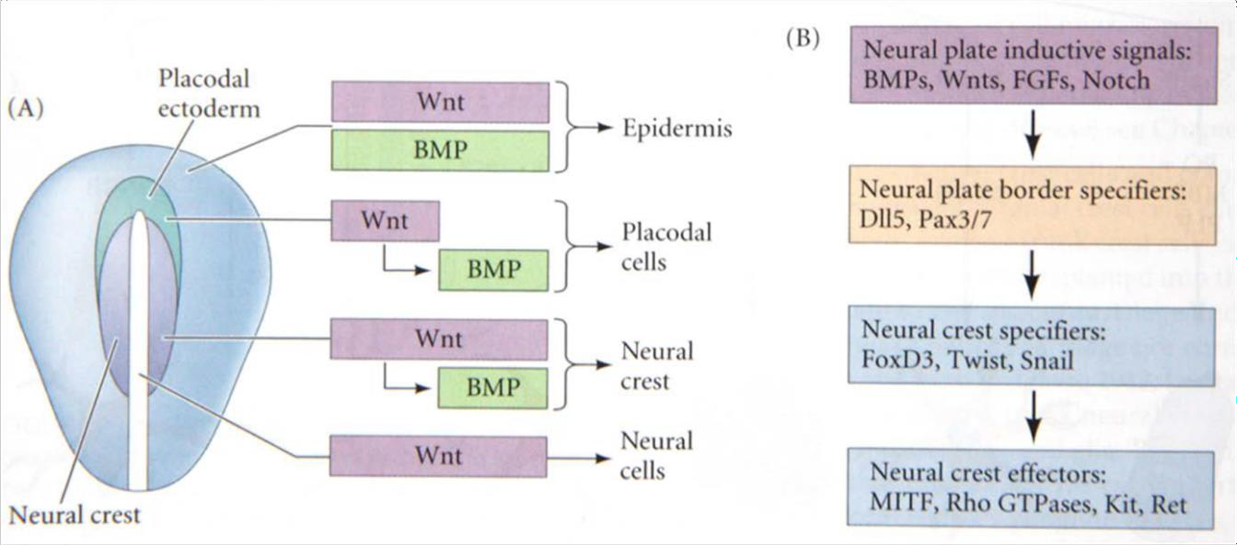

Sox9, Sox10

## Sox10 Mediate Neural Crest Cell Differentiation

1. Delamination of neural crest cells from the neural tube.
2. Differentiation of the numerous neural crest lineages.
3. Sox10 binds to enhancers of target genes, which encode the neural crest effectors.

## Regionalization of the Neural Crest

1. Cranial NCCs: Craniofacial mesenchyme, which differentiates into the cartilage, bone, cranial neurons, glia, pigment cells, and connective tissues of the face. These cells also enter the pharyngeal arches and give rise to thymic cells, the odontoblasts of the tooth primordia, and the bones of the middle ear and jaw.
2. Cardiac NCCs: A subregion of cranial NCC. Produce the entire muscular-connective tissue wall of the large arteries and the septum of the heart.
3. Trunk NCCs: One group migrates ventrolaterally through the anterior half of each somatic sclerotome and form the dorsal root ganglia containing the sensory neurons. Cells that continue traveling more ventrally form the sympathetic ganglia, the adrenal medulla, and the nerve clusters surrounding the aorta. Another group migrates dorsolaterally, allowing the precursors of melanocytes to move through the dermis from the dorsum to the belly.
4. Vagal and sacral NCCs: These NCCs generate the parasympathetic (enteric) ganglia.

## Mechanisms of Neural Crest Migration

1. What signals initiate migration? (EMT – activation of the Wnt genes by BMPs)
2. When does the migratory agent (cells) become competent to respond to these signals? (when the somites cease making noggin)
3. How do the migratory agents know the route to travel? (attractant and repellent)
4. What signals indicate that the destination has been reached? (fully differentiated, MET???)

## Summary: the Differentiation of the Trunk Neural Crest

1. Autonomous factors — *Hox* genes distinguishing trunk and cranial neural crest cells, MITF committing cells to a melanocytes lineage.
2. Specific conditions of the environment (vagal and thoracic neural crest).
3. A combination of two.
4. The fate of an individual neural crest cell is determined both by its starting position (anterior—posterior along the neural tube) and by its migratory path.

## Summary: Cranial Neural Crest

1. The head, comprising the face and the skull, is largely the product of the cranial neural crest.
2. Like the trunk neural crest, the cranial neural crest can form pigment cells, glial cells, and peripheral neurons.
3. It can generate bones, cartilage, and connective tissue.
4. In mice and humans, the cranial NCCs migrate from the neural folds even before they have fused together.
5. Subsequent migration of NCCs is directed by an underlying segmentation (rhombomeres) of the hindbrain.
6. The cranial NCCs migrate ventrally into the pharyngeal arches and the frontonasal process that forms the face.
7. The final destination of cranial NCCs will determine their eventual fate.

## Summary

1. The neural crest is a transient structure. NCCs migrate to become numerous different cell types.
2. The formation of the neural crest depends on interactions between the prospective epidermis and the neural plate. Paracrine factors from these regions induce the formation of TFs that enable neural crest cells to emigrate.
3. Some neural crest cells are capable of forming a large repertoire of cell types. Other neural crest cells may be restricted even before migration. The final destination of the neural crest cell can sometimes change its specification.
4. The path a neural crest cell takes depends on the extracellular environment it meets.
5. Trunk neural crest cells can migrate dorsolaterally into the ectoderm, where they become melanocytes. They can also migrate ventrally, to become dorsal root ganglia cells, sympathetic and parasympathetic neurons and adrenomedullary cells.
6. Trunk neural crest cells will migrate through the anterior portion of each sclerotome, but not through the posterior portion of a sclerotome. Semaphorin and ephrin proteins expressed in the posterior portion of each sclerotome prevent neural crest cell migration.
7. Cranial neural crest cells enter the pharyngeal arches to become cartilage of the jaw and the bones of the middle ear. They also form the bones of the frontonasal process, the papillae of the teeth, and the cranial nerves.

## QUIZ

### Why the neural crest cell lineages are called as “the fourth germ layer”? Please give a few examples of which cell types neural crest cells can generate.

Because of its multipotency, long range migration through embryo, and its capacity to generate a prodigious

number of differentiated cell types, although derived from the ectoderm, the neural crest has been called the fourth germ layer. Cell types NCCs can generate include but are not limited to connective tissue, peripheral neurons, glia, pigment cells, and (in the head) bone and cartilage.

### What’s the main differences between trunk and cranial neural crest cells? And what’s the underlying

molecular mechanism?

Cranial crest cells can form cartilage, muscle, and bone, whereas trunk neural crest cells cannot. The inability of the trunk neural crest to form skeleton is most likely due to the expression of *Hox* genes in the trunk neural crest.

### Trunk neural crest cells will migrate through the anterior portion of each sclerotome, but not through

the posterior portion of a sclerotome. What’s the underlying molecular mechanism?

Semaphorin and ephrin proteins expressed in the posterior portion of each sclerotome can prevent neural crest cell migration via Eph and Neuropilin-2 receptors.

### What are mechanisms of neural crest migration?

* 1. What signals initiate migration? (EMT – activation of the Wnt genes by BMPs)
  2. When does the migratory agent (cells) become competent to respond to these signals? (when the somites cease making noggin)
  3. How do the migratory agents know the route to travel? (attractant and repellent)
  4. What signals indicate that the destination has been reached? (fully differentiated, MET???)

### What are mechanisms of neural crest differentiation?

* 1. Sox10 mediates the differentiation of neural crest cells by binding to enhancers of target genes, which encode the neural crest effectors.
  2. Autonomous factors determine the fate of neural crest, e.g. *Hox* genes distinguish trunk and cranial neural crest cells, MITF commits cells to a melanocytes lineage, etc.
  3. Specific conditions of the environment (vagal and thoracic neural crest).
  4. The eventual fate is usually dependent on the combination of the above two.
  5. The fate of an individual neural crest cell is determined both by its starting position (anterior—posterior along the neural tube) and by its migratory path.

# Stem cell biology

## Characteristics of pluripotent stem cells：

Molecular properties:

1. Expression of stem cell markers: OCT4, NANOG, SOX2, etc.
2. Epigenetic status: loosed chromatins, DNA hypomethylation, X-chromosome activation. Phenotypic properties:
   1. *In vitro* differentiation, produce progenies that belong to all three germ layers [form embryonic bodies *in vitro*].
   2. Teratoma formation *in vivo*, embryo chimeras.
   3. Reconstitute a fetus (gestational complementation, germline transmission, tetraploid complementation, and single-cell chimeras).

## Assays employed to reveal the developmental potential of pluripotent stem cells

1. *In vitro* differentiation;
2. Teratoma formation;
3. Chimera formation;
4. Germline transmission;
5. Tetraploid complementation;
6. Single-cell chimera formation.

## How to derive pluripotent stem cells?

1. ES cells: cells derived from Inner Cell Mass – “ICM”; cells develop into the fetus;
2. Somatic cell nuclear transfer (SCNT, unfertilized oocytes required);
3. Reprogrammed (viral transduction with reprogramming factors) - induced pluripotent stem cells (iPSCs);
4. Cell fusion (fusion with ESCs).

## What can pluripotent stem cells do?

1. Study human development in culture dishes;
2. Disease modeling;
3. Drug screening;
4. Produce functioning terminal cells to replenish damaged/lost cells and tissue.

## Why develop induced pluripotent stem cells?

1. Ethical issues:
   * ES cells — destroying human embryos
   * Somatic nuclear transfer — requiring unfertilized oocytes
2. Host—graft rejection issues

**Adult stem cells: Cells able to replenish a tissue**

|  |  |
| --- | --- |
| **Traditional view** | **Current additions** |
| **Rare:**  neural stem cells, hematopoietic stem cells | **Can be abundant:**  Digestive tract, testis |
| **Quiescent:**  Muscle stem cells, hair bulge stem cells | **Can be active:**  Intestinal stem cells, epidermal stem cells |
| **Hierarchy:**  Hematopoietic stem cells | **Plasticity:** +4 intestinal crypt cells, liver  **Coexisting stem cell types:** skin, mammary, prostate |

**A comparison between iPSC derived progenies and trans-differentiation (QUIZ)**

|  |  |  |
| --- | --- | --- |
|  | **Differentiation from ES/iPS cells** | **Trans-differentiation** |
| **Pros** | 1. Known factors for iPSC reprogramming 2. Can be virus free 3. Cultured in vitro — controllable 4. Can generate large amount of cells 5. May produce all cell types | 1. Single step 2. Can be achieved in vivo 3. Less prone to mutation 4. Can be virus free |
| **Cons** | 1. Multiple steps 2. Mutation culmination — cancer | 1. Specific combinations (unknown) for each cell type 2. Low efficiency, very limited numbers of cells |

**Four Different Modes of Regeneration (QUIZ)**

|  |  |  |
| --- | --- | --- |
|  | **Process** | **Examples** |
| **Stem-cell mediated regeneration** | Stem-cell mediated regeneration | Planarian/flatworm, skin, hair, blood |
| **Epimorphosis**  新建再生、割处再生、表变态 | Dedifferentiation and re-  differentiation | Amphibian limb |
| **Morphallaxis**  变形再生、形态重组 | Re-patterning of existing  tissues, little new growth | Hydra |
| **Compensatory regeneration** | Differentiated cells divide | Mammalian liver |

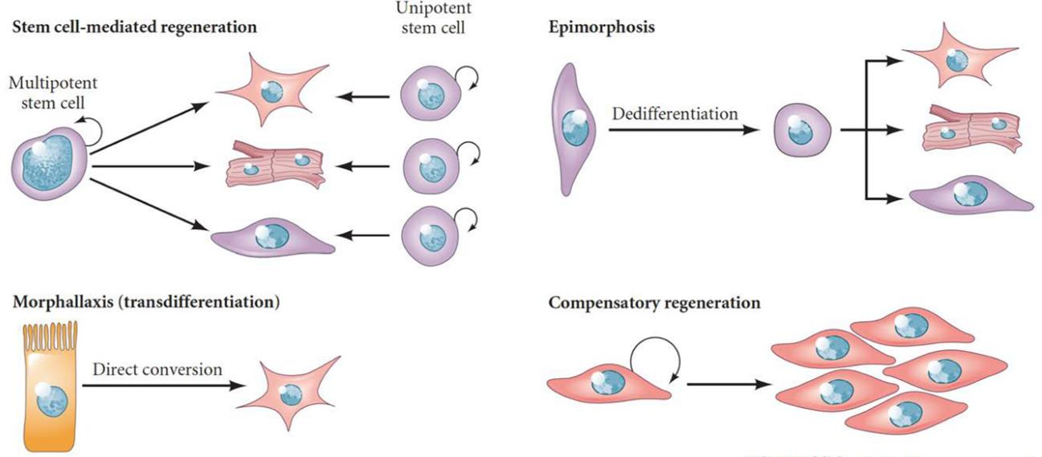

**QUIZ**

### What are pluripotent and adult stem cells?

Pluripotent stem cells are self-renewing cells with the capacity to form representative tissues of all three germ layers of the developing embryo—ectoderm, mesoderm and endoderm, as well as the germ lineage, but typically provide little or no contribution to the trophoblast layers of placenta. Adult stem cells are found in the tissues of mature organs which are usually involved in replacing and repairing tissues of that particular organ. Pluripotent stem cells are able to make an animal while adult stem cells are involved in tissue replenishment.

1. What are the similarities and differences between totipotency, pluripotency and multipotency? Totipotency describes the potency of certain stem cells to form all structures of an organism, which can form both trophoblast cells and the embryo precursor cells. Pluripotent stem cells can generate any cell type in the body, but are not able to form the trophoblast. Multipotent stem cells are adult stem cells whose commitment is limited to a relatively small subset of all the possible cells of the body.

### How to experimentally characterize pluripotent stem cells? Checklist, gold standard?

**Functional definition of pluripotency:** *In vitro* differentiation, Teratoma formation, Chimera formation, Germline transmission, Tetraploid complementation, Single-cell chimera formation.

**Molecular definition of pluripotent state:** Core markers (core TFs: Oct4, Sox2 and Nanog; surface marker and AP activity); State markers (global DNA methylation levels, activation of marker TFs, Oct4 enhancer usage, X chromosome status).

### Please describe the experiments of tetraploid complementation.

Normal mammalian somatic cells are diploid. Tetraploid complementation assay starts with producing a tetraploid cell by taking an embryo at the two-cell stage and fusing the two cells by applying an electrical current. The resulting tetraploid cell will continue to divide, and all daughter cells will also be tetraploid. Such a tetraploid embryo can develop to form the extra-embryonic tissue (placenta etc.), however a proper fetus will rarely develop. In the tetraploid complementation assay, one now combines such a tetraploid embryo with normal diploid embryonic stem cells. The embryo will then develop normally. The fetus is exclusively derived from the ES cell, while the extra-embryonic tissues are exclusively derived from the tetraploid cells.

### What can embryonic stem cells and iPSCs do?

* 1. Study human development in culture dishes;
  2. Disease modeling;
  3. Drug screening;
  4. Produce functioning terminal cells to replenish damaged/lost cells and tissue such as neural cells, pancreatic islet cells, muscle cells, immune cells, etc.

### What’re the advantages of iPSCs?

* 1. Do not destroy human embryos because iPSCs are derived directly from adult tissues, bypassing the need for embryos;
  2. Do not require unfertilized oocytes;
  3. No host—graft rejection issues because each individual could have their own pluripotent stem cell line.

### What are the stem cell niches?

Stem cell niches are particular locations (environment) that allow the controlled self-renewal and survival of the stem cells within the niche and the controlled differentiation of those stem cell progenies that leave the niche.

### How to experimentally characterize adult stem cells?(畅畅)

The majority of researchers who lay claim to having identified adult stem cells rely on two of these characteristics—appropriate cell morphology, and the demonstration that the resulting differentiated cell types display surface markers that identify them as belonging to the tissue; a single adult stem cell can generate a line of genetically identical cells, which then gives rise to all the differentiated cell types of the tissue in which it resides.

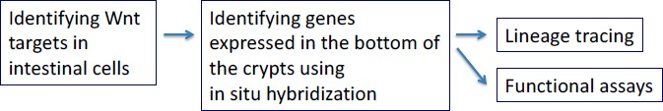In general, three methods are used to determine whether candidate adult stem cells give rise to specialized cells. Adult stem cells can be labeled *in vivo* and then they can be tracked. Candidate adult stem cells can also be isolated and labeled and then transplanted back into the organism to determine what becomes of them. Finally, candidate adult stem cells can be isolated, grown *in vitro* and manipulated, by adding growth factors or introducing genes that help determine what differentiated cells types they will yield.

Sample logic flow for finding candidate adult stem cells and marker genes

### Please describe the experimental proof showing planarian regeneration is mediated by clonogenic neoblasts (stem-cell mediated regeneration) rather than regeneration blastema.

Irradiation with 1750 rad kills almost all neoblasts. If even one survives, a single clonogenic neoblast can divide to generate a colony of dividing cells that will ultimately produce the differentiated cells of the organs. Irradiation with 6000 rad eliminates all dividing cells. Transplanting a single clonogenic neoblast from a donor strain results not only in the production of all the cell types in the organism but also restores the organism’s capacity for regeneration.

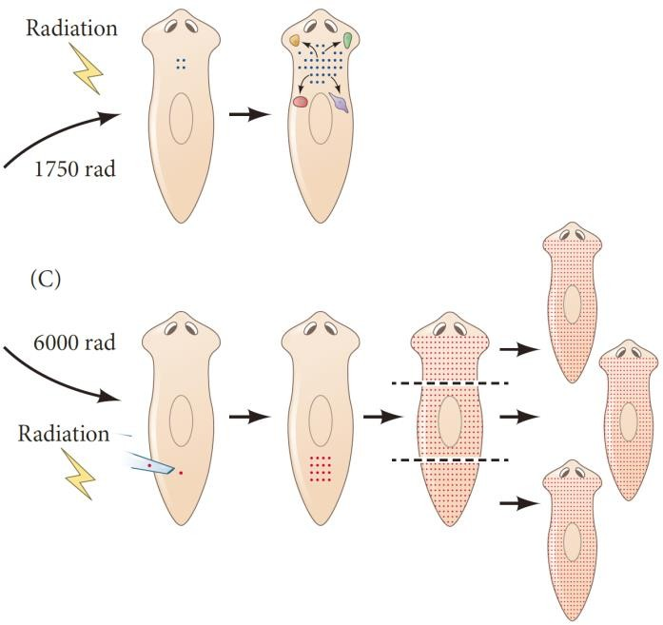

# Somatogenesis

## Major Lineages of the Amniote Mesoderm：

These subdivisions are thought to be specified along the mediolateral (center-to-side) axis by increasing amounts of BMPs.

1. **Chordamesoderm** (脊索中胚层) forms the notochord.
2. **Paraxial/somitic** (轴旁/体节) **mesoderm** forms the somites and head mesoderm.
   * Somites are blocks of mesodermal cells on either side of the neural tube, which produce muscle and many of the connective tissues of the back (dermis, muscle, vertebrae and ribs).
   * Head mesoderm (anterior), along with the cranial neural crest, forms the skeleton, muscles, and connective tissue of the face and skull.
   * The paraxial mesoderm is specified by the antagonism (Noggin) of BMP signaling.
3. **Intermediate mesoderm** forms the urogenital system, including the kidneys, the gonads, and their associated ducts, as well as the adrenal cortex.
4. **Lateral plate mesoderm**
   * Splanchnic (脏壁) mesoderm: heart, blood vessels, blood cells.
   * Somatic mesoderm (体壁): lining of the body cavities, pelvic, limb skeleton.
   * Extraembryonic mesoderm.

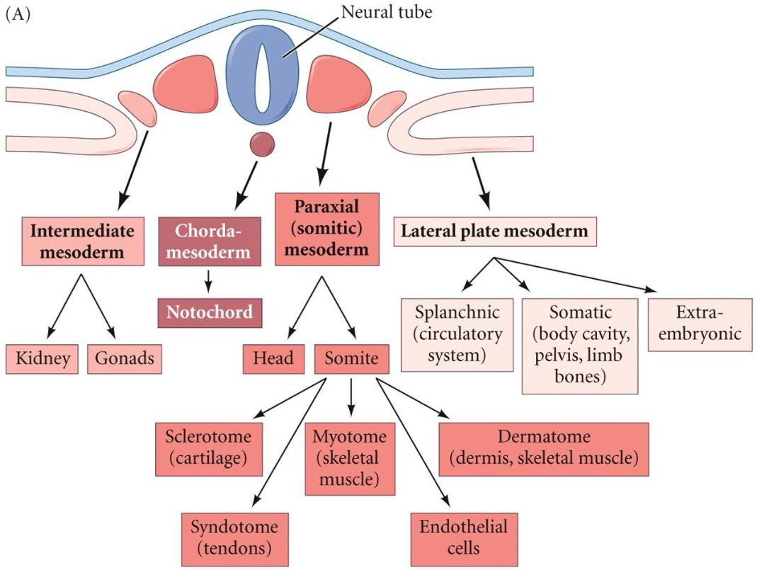

## Formation of the Somites (Somitogenesis)

1. **Generation of the presomitic mesoderm (PSM)**

The first somite appears in the anterior portion of the trunk, and new somites bud off from the rostral end of the presomitic mesoderm (PSM) at regular intervals.

1. **Periodicity: clock and wavefront model for somitogenesis**

The segmentation clock drives the dynamic and periodic mRNA expression of a number of so-called clock genes across the PSM in a posterior to anterior fashion, with a periodicity that matches somite formation. The wave of expression is not due to cell movement but to individual cells turning on and off gene expression in a synchronized and periodic fashion. This is an intrinsic property of the PSM tissue. Once the wave reaches the anterior limit of the PSM, a somite pair buds off and a new wave of expression is initiated in the posterior PSM.

1. **Synchronicity**
2. **Fissure formation (separation of the somites)**
3. **Epithelialization**
4. **Specification of the somites along the anterior—posterior axis**
5. **Differentiation**

## What are the segmentation clock pacemaker (experiment logic flow)：

The periodic expression of the Notch ligands could trigger the molecular oscillations of Notch signaling. At least in the case of the Notch pathway, the generation and maintenance of oscillations along the PSM have been shown to rely on negative feedback loops driven by unstable negative regulators of the pathway that are encoded by the clock genes.

1. The expression domains of Hes7 protein and mRNA are overlapped but different from each other.
2. In all phases, the *Hes7* intron signals (nascent mRNA transcripts) and Hes7 protein-positive regions are mutually exclusive, indicating that *Hes7* transcription occurs only in the Hes7 protein-negative regions (Intron probes recognize only nascent transcripts in the nucleus).
3. *Hes7* transcription is constitutively activated throughout the PSM in the absence of functional Hes7 protein.
4. Stabilization of Hes7 protein constitutively represses *Hes7* transcription.

## Molecule basis of Synchronicity

1. Reciprocal Signaling between neighboring cells.
2. Positive feedback loop.
3. A small bias can be amplified—cell-fate stabilized.

## Acceleration of Clock Oscillation by Downregulation of *Her1/7*

1. *her*-MO (morpholino antisense oligos to knockdown gene expression) cells are expected to continuously activate Notch signaling in surrounding cells, because the expression of deltaC is upregulated due to the absence of Her1/7 dependent repression.
2. This segment shift activity of *her*-MO cells was also found to depend upon the function of DeltaC, as its depletion in donor cells abolishes the segment-shift activity of *her*-MO cells.

## Translating the Periodic Signal into Repeated Segments (The Establishment of the Segmental Pattern of the Presumptive Somites, Fissure Formation)

1. Antagonistic gradients of FGF/Wnt signaling and retinoic acid signaling position the determination front.
2. As the embryo extends posteriorly, the determination front moves caudally.
3. Cells that reach the determination front are exposed to the periodic clock signal, initiating the segmentation program and activating simultaneously expression of genes such as Mesp2 in a stripe domain that prefigures the future segment. This establishes the segmental pattern of the presumptive somites.

## Fate Specification of the Somitic Derivatives

1. The specification of a somite is accomplished by the interaction of several tissues.
2. The location of the somitic regions place them close to different signaling centers, such as the notochord (source of Shh and Noggin), the neural tube (source of Wnts and BMPs), and the surface epithelium (also a source of Wnts and BMPs).

## Muscle Development:

1. All the skeletal muscles in the vertebrate body (with the exception of the head muscles) come from the dermomyotome of the somite.
2. Myogenic regulatory factors (MRF) are bHLH TFs, including MyoD, Myf5, myogenin and Mrf4.
3. Each member of this family can activate the genes of the other family members, leading to positive feedback regulation so powerful that the activation of an MRF in nearly any cell in the body converts that cell into muscle.

## QUIZ

### What are major derivatives of the mesoderm?

* 1. **Chordamesoderm** forms the notochord.
  2. **Paraxial/somatic mesoderm** forms the somites (muscle and connective tissues of the back) and head mesoderm (skeleton, muscle, connective tissues of the face and skull).
  3. **Intermediate mesoderm** forms the urogenital system (kidneys, gonads, as well as the adrenal cortex).
  4. **Lateral plate mesoderm** includes splanchnic mesoderm (heart, blood vessels, blood cells), somatic mesoderm (lining of the body cavities, pelvic, limb skeleton), and extraembryonic mesoderm.

### What are the molecular basis for periodic clocks in somitogenesis?

The segmentation clock drives the dynamic and periodic mRNA expression of a number of so-called clock genes across the presomitic mesoderm (PSM) in a posterior to anterior fashion, with a periodicity that matches somite formation. The wave of expression is not due to cell movement but to individual cells turning on and off gene expression in a synchronized and periodic fashion. Once the wave reaches the anterior limit of the PSM, a somite pair buds off and a new wave of expression is initiated in the posterior PSM. The generation and maintenance of oscillations along the PSM have been shown to rely on negative feedback loops driven by unstable negative regulators of the pathway that are encoded by the clock genes.

### The molecular basis for synchronicity inside a somite.

* 1. Reciprocal Signaling between neighboring cells.
  2. Positive feedback loop.
  3. A small bias can be amplified—cell-fate stabilized.

### How to translate the periodic signal into repeated segments of somites?

* 1. Antagonistic gradients of FGF/Wnt signaling and retinoic acid signaling position the determination front.
  2. As the embryo extends posteriorly, the determination front moves caudally.
  3. Cells that reach the determination front are exposed to the periodic clock signal, initiating the segmentation program and activating simultaneously expression of genes such as Mesp2 in a stripe domain that prefigures the future segment. This establishes the segmental pattern of the presumptive somites.

### Please summarize the process of muscle development.

* 1. All the skeletal muscles in the vertebrate body (with the exception of the head muscles) come from the dermomyotome of the somite.
  2. Myogenic regulatory factors (MRF) are bHLH TFs, including MyoD, Myf5, myogenin and Mrf4.
  3. Each member of the MRF family can activate the genes of other members, leading to positive feedback regulation so powerful that the activation of an MRF in nearly any cell in the body converts that cell into muscle.
  4. Myoblasts align together and fuse their cell membranes to form a single large cell with several nuclei named myofiber, which forms the basic unit of muscle.
  5. Satellite cells residing along the adult muscle fibers are responsible for the growth and regeneration of muscles.

### What are the key features of myogenic transcription factors?

Each member of the MRF family can activate the genes of other members, leading to positive feedback regulation so powerful that the activation of an MRF in nearly any cell in the body converts that cell into muscle.

# Limb development

## How to Identify the Limb Field?

1. Removing certain groups of cells and observing that a limb does not develop in their absence.
2. Transplanting groups of cells to a new location and observing that they form a limb in this new place.
3. Marking groups of cells with dyes or radioactive precursors and observing that their descendants participate in limb development (lineage-tracing).

## Emergence of the Limb Bud

1. Limb development begins when mesenchyme cells migrate from the limb fields of the lateral plate mesoderm (to form the limb skeletal precursor cells ) and from the somites (the limb muscle precursor cells) at the same level.
2. These mesenchymal cells accumulate under the skin (ectodermal) tissue to create a circular bulge called a limb bud.
3. Vertebrates have no more than four limb buds per embryo, and limb buds are always paired opposite each other with respect to the midline.

## Induction of the early limb buds: Wnt proteins and fibroblast growth factors (Fgfs)

1. Hox proteins establish conditions for the synthesis of retinoic acid (RA) in the lateral plate mesoderm.
2. RA causes the induction of transcription factors Tbx5 (forelimb) and Tbx4 (hindlimb).
3. The Tbx transcription factors (TFs) induce Fgf10 in the lateral plate mesoderm.
4. Fgf10 induces Fgf8 expression in the ectoderm via Wnt signaling.
5. The positive feedback loop between Fgf10 in the mesoderm and Fgf8 in the ectoderm initiates the outgrowth of the limb and forms the apical ectodermal ridge (AER).

## Axis formation

|  |  |
| --- | --- |
| Proximal—Distal | Fibroblast growth factor (FGF), RA |
| Anterior—Posterior | Sonic hedgehog (Shh) |
| Dorsal—Ventral | Wnt7a |

**Generating the Proximal-Distal Axis of the Limb**

1. The apical ectodermal ridge (AER)
2. Specifying the limb mesoderm: determining the proximal—distal polarity of the limb skeleton
3. The dual-gradient model of limb patterning

## Roles of AER

1. Maintaining the mesenchyme beneath it in a plastic, proliferating state that enables the proximal—distal growth of the limb.
2. Maintaining the expression of those molecules that generate the anterior—posterior (thumb-pinkie) axis.
3. Interacting with the proteins specifying the anterior—posterior and dorsal—ventral (knuckle-palm) axes so that each cell is given instructions on how to differentiate.

## Control of Proximal-distal Specification by the Distal (Progress Zone) Mesenchyme

1. An extra set of ulna and radius formed when an early wing-bud progress zone was transplanted to a late wing bud that had already formed ulna and radius.
2. Lack of intermediate structures seen when a late wing-bud progress zone was transplanted to an early wing bud.

## The Dual-gradient Model of Limb Patterning

1. Retinoic acid (RA) proximalizes the bones forming from the transplanted mesenchyme.
2. FGFs and Wnts distalize the bones forming from the transplanted mesenchyme.

## How does the mesenchyme specify the proximal-distal axis?

A balance between the proxmalizing of bones by RA from the flank and the distalizing of bones by the FGFs and Wnts of the AER. The opposing gradients may accomplish this balance by laying down a segmental pattern of different transcription factors in the mesenchyme.

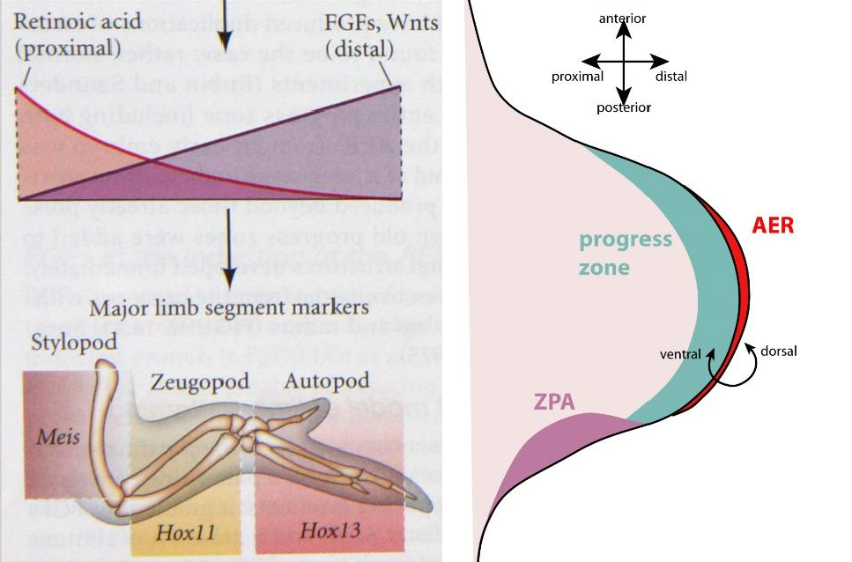

## Specifying the Anterior-posterior Axis of the Limb

Sonic hedgehog (Shh) defines the zone of polarizing activity (ZPA), therefore specifies the anterior-posterior axis.

## Specification of the digit

1. Specification of the digit is primarily dependent on the amount of time the *Shh* gene is expressed and only a little bit on the concentration of Shh protein that other cells receive.
2. Regulation of digit identity by BMP concentration in the interdigital mesoderm posterior to the digit.
3. Regulation of digit identity by BMP concentrations in the interdigital space anterior to the digit and by Gli3.

## Wnt7a Specifies the Dorsal-Ventral Axis

The dorsal—ventral axis is formed in part by the expression of Wnt7a in the dorsal portion of the limb ectoderm.

1. Is the Wnt7a an activating or inhibitory signal?
2. Where do you expect Wnt7a would express, dorsal or ventral side?
3. What if the Wnt7a is overexpressed at the ventral side of the limb?

## Cell Death and the Formation of Digits and Joints

The signal for apoptosis in the autopod is provided by the BMP proteins (BMP2/4/7).

## Coordinating the Three Axes

1. In the limb bud, Fgf10 from mesenchyme generated by the lateral plate mesoderm activates Wnt signaling in the ectoderm, which in turn induces synthesis of Fgf8 in the region near the AER. Fgf8 activates Fgf10, causing a positive feedback loop.
2. As the limb bud grows, Shh in the posterior mesenchyme creates a new signaling center that induces posterior-anterior polarity, and also activates Gremlin (Grem1) to prevent mesenchymal BMPs from blocking FGF synthesis in the AER.
3. 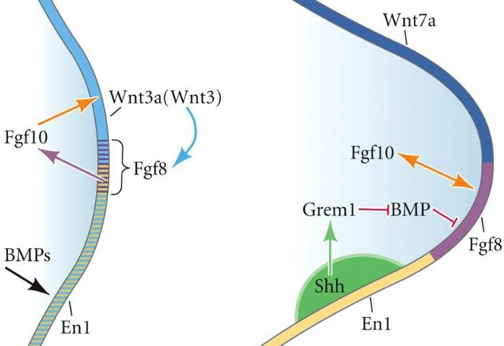At the end of limb patterning, BMPs are responsible for simultaneously shutting down the AER, indirectly shutting down the ZPA, and inhibiting the Wnt7a signal along the dorsal-ventral axis (the BMP signal eliminates growth and patterning along all axis).

## Summary

1. The positions where limbs emerge from the body axis depend on Hox gene expression.
2. The positive feedback loop between Fgf10 in the mesoderm and Fgf8 in the ectoderm initiates the outgrowth of the limb and forms the apical ectodermal ridge (AER).
3. Two opposing gradients, one of Fgfs and Wnts from the AER, the other of retinoic acid (RA) from the flank, pattern the limb.
4. The anterior—posterior axis is defined by the expression of Sonic hedgehog (Shh) in the zone of polarizing activity (ZPA), a region in the posterior mesoderm of the limb bud.
5. Shh specifies digits in at least two ways. It works through BMP inhibition in the interdigital mesenchyme, and it also regulates the proliferation of digit cartilage.
6. Mutations in the long-range enhancer for Shh can cause polydactyly (多指趾畸形) by creating a second

ZPA in the anterior margin of the limb bud.

1. The dorsal—ventral axis is formed in part by the expression of Wnt7a in the dorsal portion of the limb ectoderm.

## QUIZ

### How does the forelimb grow differently other than the hindlimb?

Retinoic acid (RA) causes the induction of transcription factors Tbx5 and Tbx4. Tbx5 leads to forelimb development while Tbx4 leads to hindlimb formation.

### What is AER, and what roles does AER play in limb development?

AER is a structure that forms from the ectodermal cells at the distal end of each limb bud and acts as a major signaling center to ensure proper development of a limb. AER plays 3 roles in limb development:

* 1. Maintaining the mesenchyme beneath it in a plastic, proliferating state that enables the proximal— distal growth of the limb.
  2. Maintaining the expression of those molecules that generate the anterior—posterior (thumb-pinkie) axis.
  3. Interacting with the proteins specifying the anterior—posterior and dorsal—ventral (knuckle-palm) axes so that each cell is given instructions on how to differentiate.

### What is ZPA, and what roles does ZPA play in limb development?

Zone of polarizing activity (ZPA) is a small block of mesodermal tissue near the posterior junction of the young limb bud and the body that contains signals (Shh) which instruct the developing limb bud to form along the anterior—posterior axis.

### Why do fingers form at one end of the limb and nowhere else? (proximal-distal axis)

Retinoic acid (RA) proximalizes the bones forming from the mesenchyme while FGFs and Wnts distalize it. There is a balance between the proxmalizing of bones by RA from the flank and the distalizing of bones by the FGFs and Wnts of the AER. The opposing gradients may accomplish this balance by laying down a segmental pattern of different transcription factors in the mesenchyme.

### How is it that the little finger (twinkie) develops at one edge of the limb and the thumb at the other?

(anterior-posterior axis)

Sonic hedgehog (Shh) defines the zone of polarizing activity (ZPA), therefore specifies the anterior-posterior axis. Specification of the digit is primarily dependent on the amount of time the *Shh* gene is expressed and only a little bit on the concentration of Shh protein that other cells receive. Shh specifies digits in at least two ways. It works through BMP inhibition in the interdigital mesenchyme, and it also regulates the proliferation of digit cartilage.

### What’s the molecular mechanisms determining the dorsal-ventral axis of the limb?

The dorsal—ventral axis is formed in part by the expression of Wnt7a in the dorsal portion of the limb ectoderm.

### How is the growth of three axes of tetrapod limb is coordinated?

* 1. In the limb bud, Fgf10 from mesenchyme generated by the lateral plate mesoderm activates Wnt signaling in the ectoderm, which in turn induces synthesis of Fgf8 in the region near the AER. Fgf8 activates Fgf10, causing a positive feedback loop.
  2. As the limb bud grows, Shh in the posterior mesenchyme creates a new signaling center that induces posterior-anterior polarity, and also activates Gremlin (Grem1) to prevent mesenchymal BMPs from blocking FGF synthesis in the AER.
  3. At the end of limb patterning, BMPs are responsible for simultaneously shutting down the AER, indirectly shutting down the ZPA, and inhibiting the Wnt7a signal along the dorsal-ventral axis (the BMP signal eliminates growth and patterning along all axis).

# The Germ Line

## Features of the Germ Line

1. Germ cells provide the material and instructions for initiating bodies in the next generation.
2. Germ line can acquire its specification either autonomously (Nanos, Vasa, Tudor, Piwi) or by induction.
3. Germ cells usually do not arise within the gonads. Rather, the gamete progenitor cells — the primordial germ cells (PGCs) — arise elsewhere and migrate into the developing gonads.
4. Transcriptional silencing is critical for preventing the germ line from differentiating into somatic cells, and germ cell differentiation cannot commence until the disappearance of PIE-1 in later embryonic stages.

## Outline

1. Germ cell specification — Formation of the germ plasm and determination of the primordial germ cells.
2. Migration of the PGCs into the developing gonads.
3. Meiosis.
4. Differentiation of the sperm and egg cells.
5. Hormonal control of gamete maturation and ovulation.

## Germ Cell Determination in Mammals

1. In mammals, germ cells are induced in the embryo.
2. In mice, the germ cells form at the posterior region of the epiblast, posterior proximal epiblast, at the junction of the extraembryonic ectoderm, epiblast, primitive streak, and allantois(尿囊).
3. The cells that become the PGCs in mice are NOT intrinsically different from the other cells of the epiblast and contain no germ plasm. Rather, the posterior epiblast cells are induced by extraembryonic tissue.

## Germ Cell Migration in Drosophila

1. Germ cells migration in Drosophila occurs in several steps involving trans-epithelial migration, repulsion from the endoderm, and attraction to the gonads.
2. Hub cells secrete Unpaired to activate the JAK-STAT pathway in the adjacent germ stem cells to specify their self-renewal. (Stem cell niche)

## Germ Cell Migration in Mammals

The PGCs migrate through the gut and, dorsally, into the genital ridges.

## Meiosis

1. Meiosis is initiated and regulated by signals from the gonad.
2. Meiotic cells undergo two cell divisions without an intervening period of DNA replication.
3. Homologous chromosomes joined at a kinetochore pair together and recombine genetic material.

## Oogenesis

Constructing the egg involves

1. Making the nucleus haploid;
2. Building the organelles involved in fertilization;
3. Synthesizing and positioning the mRNAs and proteins used in early development;
4. Accumulating energy sources and energy producing organelles (ribosomes, yolk, and mitochondria) in the cytoplasm.

## Meiotic oogenesis in Drosophila

Cytoplasmic connections remain between the cells produced by the oogonium. Only one cell becomes oocytes. The rest 15 nurse cells pass ribosomal, mRNAs and proteins into the oocytes cytoplasm.

## Gametogenesis in Mammals

1. The PGCs that migrate to the gonads do not make their own decision to become sperm or egg. It’s the gonad they reside makes the decision.
2. One of the most fundamental sets of signals regulates the timing of meiosis, and these signals include Wnt4 and retinoic acid (RA).

## Retinoic acid (RA) determines the timing of meiosis and sexual differentiation of mammalian germ cells

1. Females: meiosis begins in the embryonic gonads.
2. Males: meiosis is NOT initiated until puberty.
3. At puberty, retinoic acid is synthesized in the Sertoli cells and induces Stra8 in sperm stem cells, then sperm stem cells become committed to meiosis.

## Spermatogenesis — Three Major Phases

Begins at puberty and occurs in the recesses(隐窝)between the Sertoli cells.

1. Proliferation of spermatogonia—sperm stem cells.
2. A meiotic phase—creating the haploid state.
3. A post-meiotic “shaping” phase—spermiogenesis: the round cells (spermatids) eject most their cytoplasm and become the streamlined sperm.

## A Mature Sperm

1. Construction of the acrosomal vesicles from the Golgi apparatus.
2. Rotation of the nucleus. The nucleus flattens and condenses, the remaining cytoplasm is discarded, and the mitochondria form a ring around the base of the flagellum.
3. Remodeling of nucleosomes — the histones of the haploid nucleus are replaced by protamines.

## Mammalian Oogenesis

The eggs mature through an intricate coordination of hormones, paracrine factors, and tissue anatomy.

## Quiz

### What are PGCs?

Primordial germ cells are gamete progenitor cells, which typically arise elsewhere and migrate into the developing gonads.

### What is germ plasm? What are the roles of germ plasm?

Germ plasm is the cytoplasmic region containing germline determinants (mRNA and proteins) that autonomously specify the primordial germ cells.

### What are the key components for constituting a functional oocyte?

* 1. Making the nucleus haploid;
  2. Building the organelles involved in fertilization;
  3. Synthesizing and positioning the mRNAs and proteins used in early development;
  4. Accumulating energy sources and energy producing organelles (ribosomes, yolk, and mitochondria) in the cytoplasm.

### What are shared features and differences between male and female gametogenesis in mammals?

Shared features:

* Both of male and female gametogenesis involve meiosis.
* The timing of meiosis and sexual differentiation are determined by retinoic acid. Differences:
* Each instance produces four sperm cells in males, while one ovum and three polar bodies in females.
* Meiosis begins in the embryonic gonads in females, while meiosis is NOT initiated until puberty in males.
* Spermatogenesis involves a post-meiotic “shaping” phase to produce mature sperm, while oogenesis do not.

### The major steps for spermatogenesis.

* 1. Proliferation of spermatogonia—sperm stem cells.
  2. A meiotic phase—creating the haploid state.
  3. A post-meiotic “shaping” phase—spermiogenesis: the round cells (spermatids) eject most their cytoplasm and become the streamlined sperm.

### The factors required for normal oogenesis.

The eggs mature through an intricate coordination of hormones, paracrine factors, and tissue anatomy.